New ideas for Plastic Problem

There are things that humankind must contribute.
It is SDGs and ESG
ESG: Environmental, social and governance
Today, I would like to talk about voluntary activities and corporate activities on plastic problem.

Plastic is very useful. Bottles, wears, wrappings and etc., are typical example.
Frozen food industry and cup ramen industry were born by using plastics.
Recently, the use of plastics has rapidly increased in the medical field to care new corona virus medical.
Therefore, plastic is an essential item in human life.

Though there is a problem with plastic.
It doesn’t rot in the ground.
Plastic ends up in oceans and water-way.
For plastics, 3R collapsed. There is no route to dispose plastic garbage.
In particular, "Reuse" and "Recycle" became difficult.
People don't feel ashamed to use plastic in their shopping bags.
It is not easy to get rid of plastic bag.
Economists also show no interest in plastic garbage.
And it is difficult to recover plastic from sea and river.
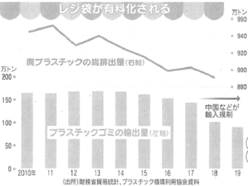
【Source Nikkei 2020.05.16】

ESG
An environmental group sued some of the world largest companies Coca-Cola, Pepsi, Nestle and other seven companies.
The lawsuit alleges they misled the public into thinking their packaging can be recycled, when most of it can’t be.
【Source CNN English Journal 202006】
My suggestions are the following two to solve the plastic problem.
Creation of plastic tax
Donate to the Plastic Processing Foundation

SDGs
NGO, Ocean Cleanup
NGO was established in 2013 by Boyan Slat to collect marine garbage.
At the age of 16, he was surprised to find more plastic than fish in Greece.
He then investigated plastic garbage.
But it turns out that no one is seriously tackling plastic problem.

He dropped out of college and launched NGO to get rid of plastic garbage all over the world.
The purpose of NGO is not to reduce the generation of plastic garbage, but to aim for a "game changer" that restores the clean sea.

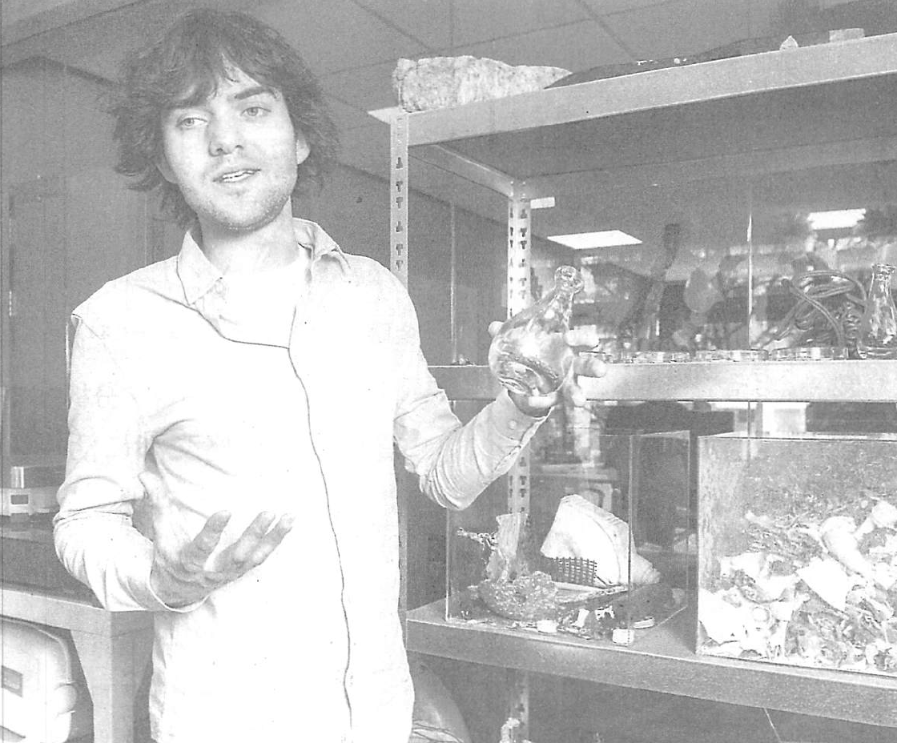

There are two businesses in NGO.
The first is the marine garbage collection, recycling, and sales business.
There is a natural place for garbage between California and Hawaii, USA.
There are 1.8 trillion pieces of plastic garbage. Its weight is 80,000 tons. This is called the Pacific garbage belt.
Ships of NGO collect marine plastic garbage.
NGO will place many ships capable of collecting 14,000 tons per year.
The plan will halve the amount of plastic garbage in the area within five years.
The image of the business is as follows.

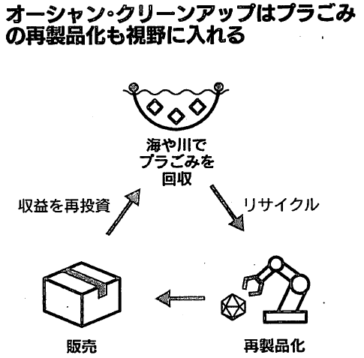

The second project is garbage collection near the sources of plastic garbage.
At the mouth of the river, special ships named Interceptor collect the flowing plastic.
It is operating in Indonesia and Malaysia. It is also planned in Vietnam and Dominica.

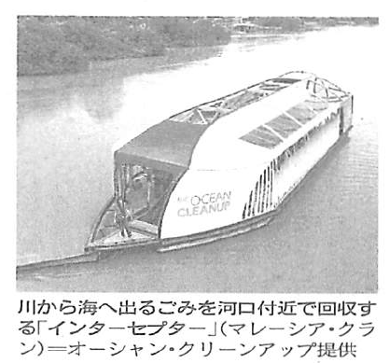

The biggest problem of NGO is fund raising.
NGO initially suffered from financial difficulties.
After raising funds with cloud funding, the cloud fund raised $2.2 million.
The investors are 3,800 individuals and companies in 160 countries.
Currently, 200 engineers and environmental experts are active.
【Source Nikkei 2020.04.29】
NGO and staff are great.
We should respect for NGO

